BOX PLOTS for ANOVA of Regions Vs Property loss

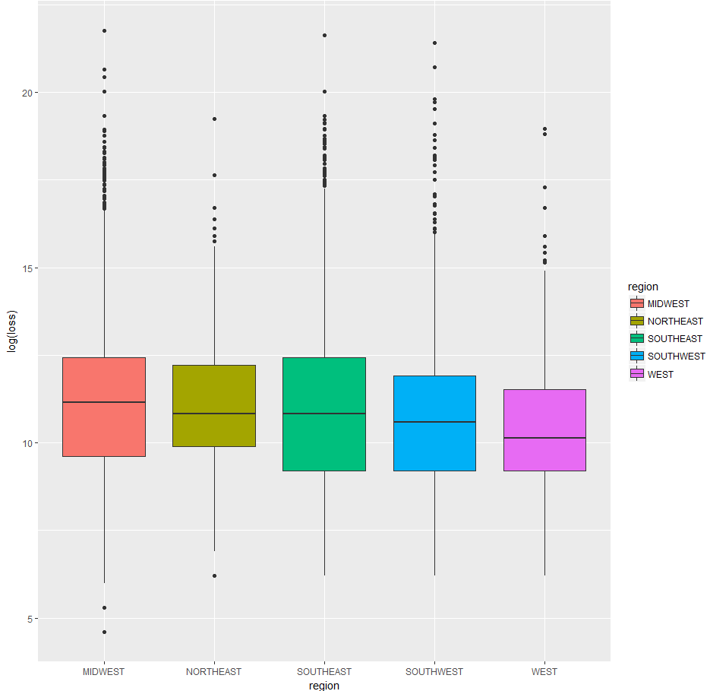

MODEL BUILT WITH ACTUAL DATA:

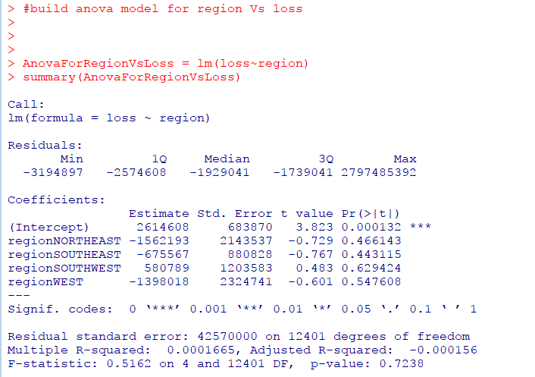

Residuals plot for region Vs Loss

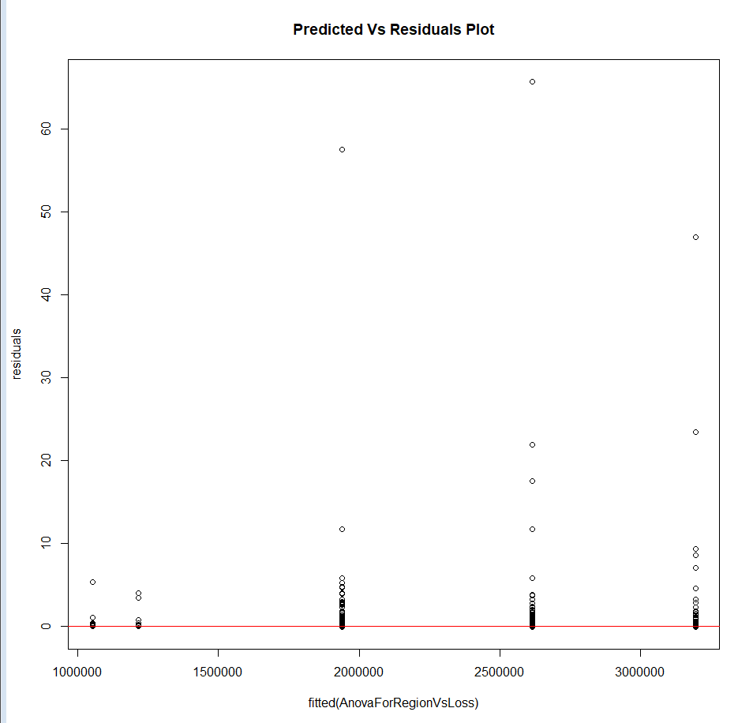

QQ PLOT

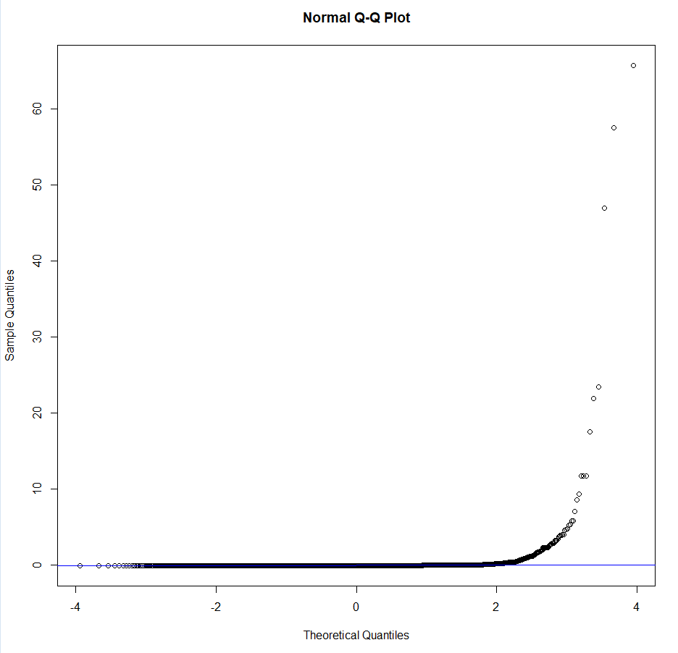

AFTER APPLYING LOG TRANSFORMATION ON LOSS

RESIDUALS PLOT

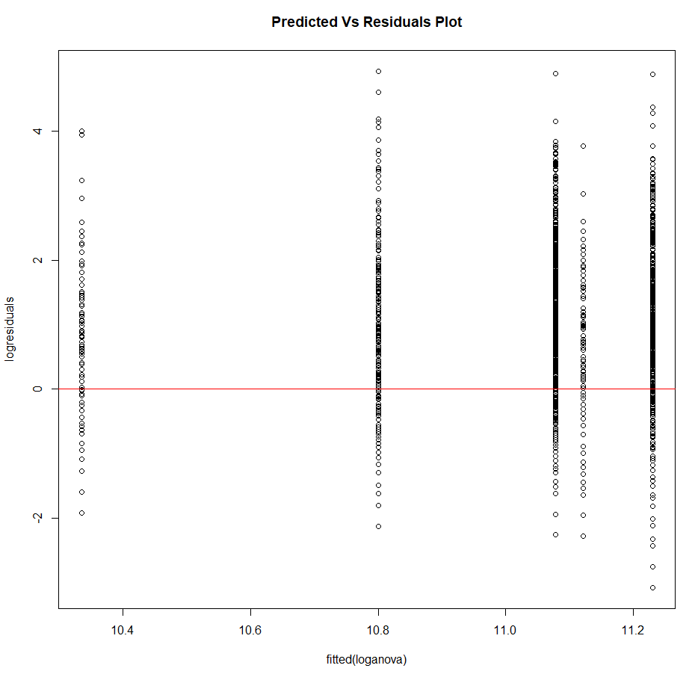

QQ PLOT

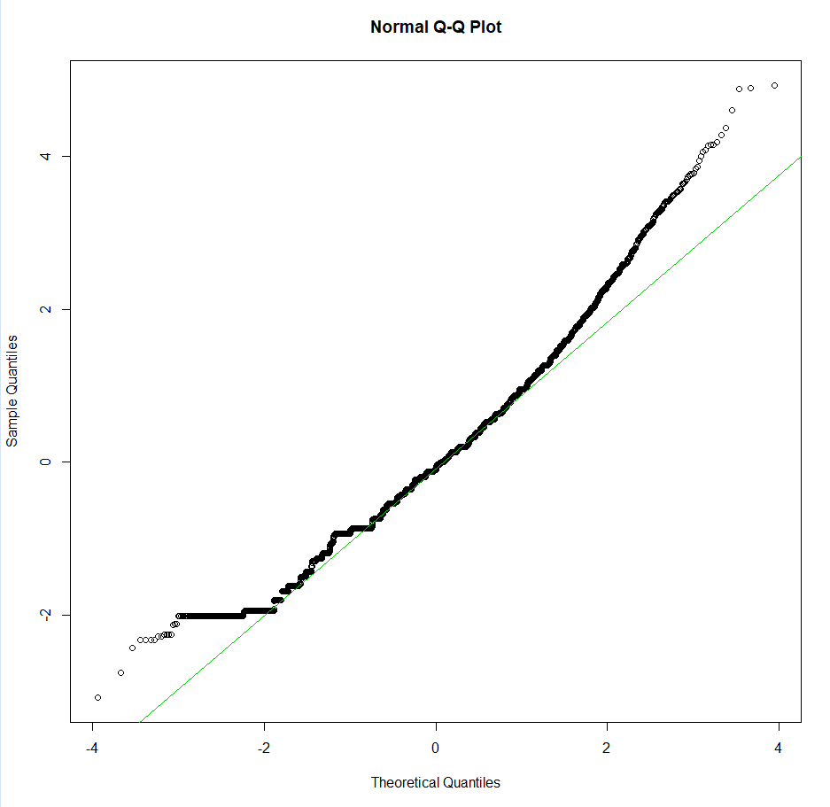

Jarque Bera test for normality

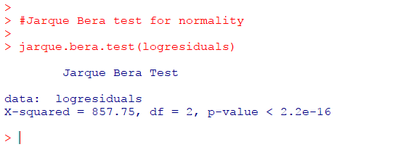

All these indicate that the residuals plot follow no constant variance and that the groups are independent and the residuals follow normal distribution

The log transformed ANOVA model is

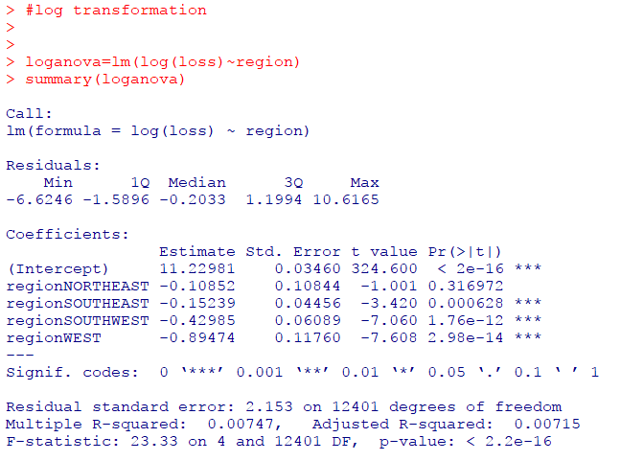

MIDWEST region is taken as the base and the differences are calculated between this region and the other regions.

F-test p-value < 0.05, this indicates that **the average property loss incurred by these regions are not the same and that there are significant differences**.